* Company Specs
  + Name: Cyclistic
  + Location: Chicago
  + Purpose: Bike-Sharing Company
* Bicycle Fleet
  + 5800 bicycles and 692 docking stations
    - Types of bicycles
      * Standard: Typical two wheeled bicycle - ***92 % of bicycles***
      * Assistive bikes - ***8 % of bicycles***
        + Reclining bikes

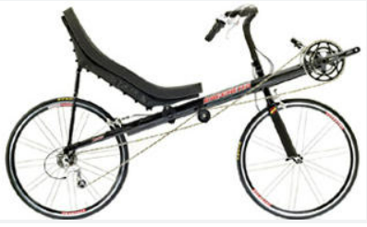

* + - * + Hand tricycles

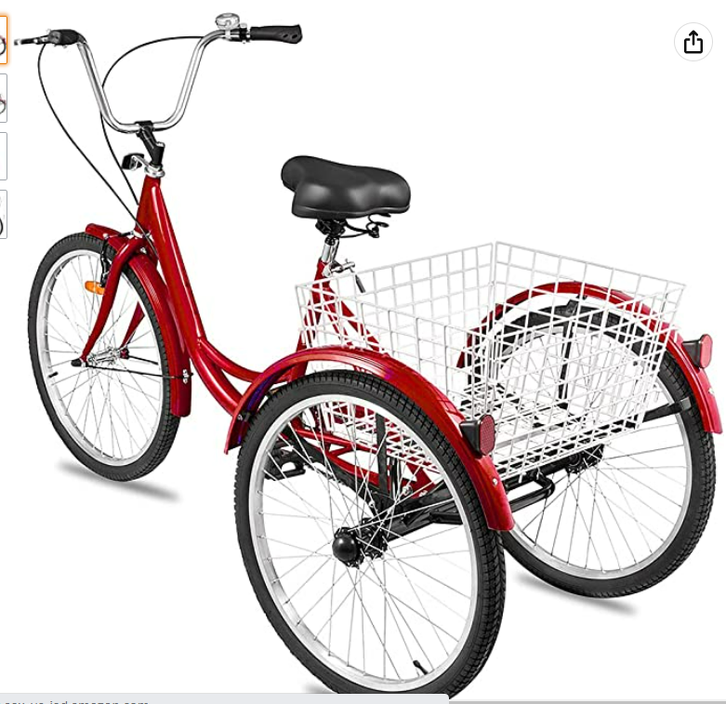

* + - * + Cargo bikes

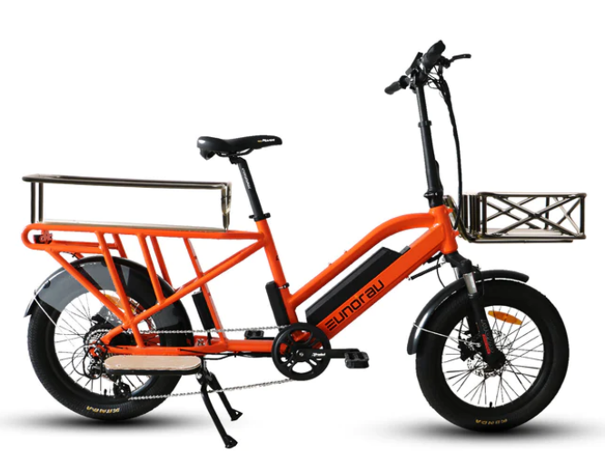

* Customers Usage Purpose
  + 70 % of customers use bicycles for leisure
  + 30 % of customers use bicycle to commute to work